**Haier HWM150-1678 Washing Machine**

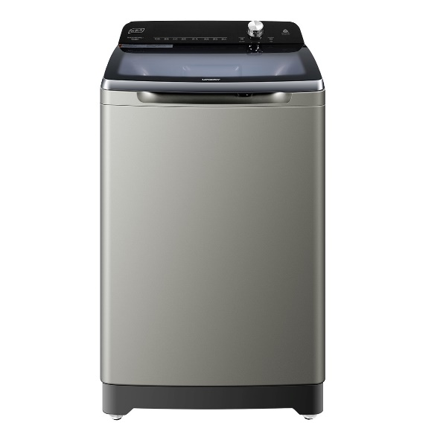

|  |  |  |  |
| --- | --- | --- | --- |
|  | **Type:** | Top Loader |  |
| **Color:** | Silver |
| **Drum Volume(L):** | Unknown |
| **Unit Dimensions(H*W*L)mm:** | Unknown |
| **RPM:** | 1300 |
| **Options:** | 9 |